Financial Performance Dashboard - Insight Report
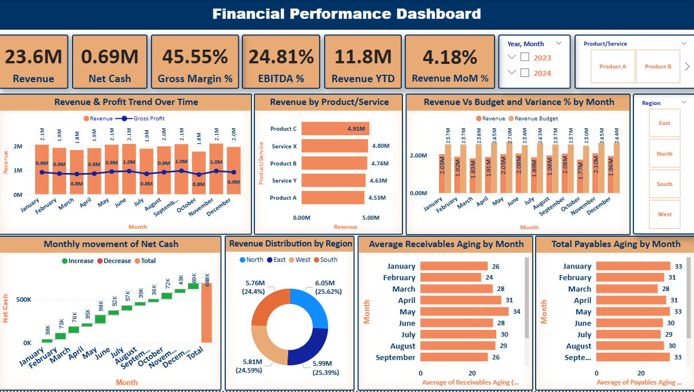
1. Overview
The Financial Performance Dashboard provides a consolidated view of the company’s financial health across revenue, profitability, cash flow, and working capital efficiency.
The data has been analyzed monthly and segmented by region and product/service, comparing performance against budgets and highlighting key financial trends.
2. Key Highlights
Revenue Performance
- Total Revenue: 23.6M
- Revenue YTD: 11.8M
- Month-over-Month Growth: 4.18%
Insight:
Revenue has shown a steady upward trend with consistent month-over-month growth. The strongest sales were recorded in December, driven primarily by Product C and Service X. However, mid-year months (June-August) show a slight dip, indicating a possible seasonal pattern.
Profitability Analysis
- Gross Margin: 45.55%
- EBITDA Margin: 24.81%
Insight:
A gross margin above 45% indicates efficient cost management relative to sales. The EBITDA margin suggests that operating expenses are significant, highlighting a need for cost optimization-particularly in Service Y, which shows lower margins compared to other offerings.
Regional Performance
- Top Performing Region: South (25.62%)
- Lowest Performing Region: East (24.59%)
Insight:
Revenue distribution across regions is fairly balanced, with all four contributing nearly equally. The South region leads slightly due to higher sales of Product C and Service X. The East region may benefit from targeted marketing or promotional activities to improve its performance.
Cash Flow Insights
- Net Cash: 0.69M
- Consistent monthly increase in net cash flow throughout the year.
Insight:
The net cash position shows steady improvement month by month, indicating effective liquidity management. December recorded the highest cumulative net cash, reflecting stronger collections or higher sales. There are no major spikes in outflows, which supports strong financial control.
Working Capital Efficiency
- Average Receivables Aging: 28-31 days
- Average Payables Aging: 27-38 days
Insight:
Receivables are being collected within approximately a 30-day period, aligning with standard credit practices. However, payables aging data seems abnormally high, which could indicate a calculation error or unusually long credit terms. This should be reviewed for accuracy or adjusted to maintain strong supplier relationships.
Budget vs Actual Performance
Insight:
Actual revenue is closely aligned with budgeted targets, with only minor deviations of ±5%. Positive variance was observed in March, May, and December, suggesting stronger performance during these months, possibly driven by seasonal or promotional factors.
3. Overall Financial Health
- Profitability: Strong margins reflect good cost control.
- Liquidity: Positive cash flow sustained through the year.
- Growth: Stable revenue increase across months.
- Areas for Improvement: Operational expense optimization and regional performance balancing.
- Data Review: Payables aging calculation should be validated.
4. Recommendations
- Strengthen cost management to improve EBITDA margins.
- Reinvest positive cash flows into high-performing regions or products.
- Review payables data to ensure accurate reporting and maintain timely payments.
- Develop targeted marketing initiatives for underperforming regions (East, West).
- Maintain the current receivables cycle to preserve cash flow stability.
5. Conclusion
The company demonstrates solid financial performance, maintaining profitability, liquidity, and consistent revenue growth. With minor adjustments in cost management and regional strategy, the overall financial position can be further strengthened for long-term stability and growth.

